Numerical Methods for Parabolic Partial Differential Equations

Hamza Farooq and Muhammad Awais
2016-CS-122, 2016-CS-109
UET Lahore, m.hamza.arif786@gmail.com, awais8111998@gmail.com

Abstract - Differential conditions are a standout amongst the most essential portrayals of the laws that utilize marvels including the development of bodies in a gravitational field or the development of populaces. Here we are going to explain numerical methods for parabolic partial differential equations.

ordinary differential equation
If all functions appearing in the equation depend only on one variable, we speak of an ordinary differential equation. Ordinary differential equations frequently describe the behavior of a system over time, e.g., the movement of an object depends on its velocity, and the velocity depends on the acceleration.

Partial differential equation
On the off chance that the capacities in the condition rely upon in excess of one variable and if the condition in this manner relies upon fractional subsidiaries, we discuss an incomplete differential condition.
A typical example is the potential equation of electrostatics. Given a domain R3, we consider

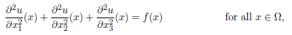
Computers have only a finite amount of storage at their disposal, they are generally unable to represent the solution u as an element of the in finite-dimensional space exactly.

- Processing Limitation
- Memory Limitation
- Limited Clock Cycles
- Can’t learn analytical methods
- Can only approximate problems

A genuinely straightforward discretization system is the technique for finite differences: we supplant the subordinates by difference remainders and supplant by a lattice h with the end goal that the difference remainders in the lattice focuses can be assessed utilizing just qualities in network focuses. For the situation of the potential condition, this prompts an arrangement of direct conditions that can be comprehended to acquire a guess uh of u.
A genuinely basic discretization strategy is the technique for finite differences: we supplant the subsidiaries by difference remainders and supplant by a framework h with the end goal that the difference remainders in the framework focuses can be assessed utilizing just qualities in network focuses. For the situation of the potential condition, this prompts an arrangement of straight conditions that can be fathomed with a specific end goal to get a guess uh of u.

Acknowledgments
- Since the Lipschitz consistent emerging in this setting is very vast, it is a smart thought to consider certain time-venturing plans that give better security and don't require us to utilize little time ventures so as to stay away from motions.
- The wave condition saves the aggregate vitality of the framework, and we might want to have a numerical plan that offers this property.
- In the event that we supplant the aggregate vitality by an appropriate discretized partner, we find that the Crank-Nicolson technique ensures that the discretized add up to vitality without a doubt stays steady.
- Keeping in mind the end goal to demonstrate consistency of finite difference strategies, we every now and again need to expect that the arrangement u is very smooth, e.g., a standard approach for the potential condition expects u to be four times persistently differentiable. This is a presumption that is as it were once in a while satisfied practically speaking, so we need to consider elective discretization plans. Variational strategies are especially appealing, since they depend on a rich reformulation of the fractional differential condition regarding Hilbert spaces.
- We can demonstrate that the variational condition has a one of a kind summed up arrangement in a Sobolev space, what's more, this summed up arrangement agrees with the established arrangement if the last exists. Variational definitions instantly offer ascent to the Galerkin discretization plot that prompts an arrangement of condition we can settle to get a guess of the arrangement. Sobolev spaces that allows us to use standard interpolation operators to construct the nite element approximation. If we use a nite element method, this system has a number of desirable properties, most importantly it is sparse

Finite difference methods for parabolic equations
Incomplete differential conditions like Poisson's condition are ordinarily used to portray frameworks that don't change after some time, e.g., the electrostatic field relating to a fixed charge dispersion or balance conditions of mechanical frameworks. Presently we center around time-subordinate halfway differential conditions, beginning with allegorical conditions that can be moved toward comparably to common differential conditions

Heat equation

Heat Equation is an example of parabolic Equation. For two dimensional Omega= (0; 1)2, it takes the form
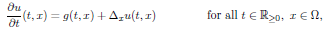
Where delta x is Laplace Operator and is applied on the variable x. To ensure uniqueness of the solution, we have to add boundary conditions.

The value u(t, x) is temperature at time belongs to R in that point where x belongs to Omega. The function g describes where and when heat is created
If g is constant with respect to time such that

We can prove that the solution u will converge to a function
That is the solution of Poisson equation
This limit is known as Equilibrium solution, and can be calculated by the techniques we have explained.
To handle the Time dependent solution, u and g are interpreted as functions in time mapping to functions in space. Let

By including the space

Then enlarging and expanding the Laplace Operator

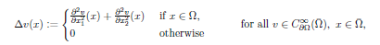

Equation (3.1) can be written as the ordinary differential Equation

Method of Lines
The method of lines was introduced to take the place of spatial differential operator by an approximation.
We have to choose the finite difference discretization method that we have already employed for the Poisson equation.
We approximate the differential operator delta by


Defined as

For all x belongs to (Omega)h and extended by

Replacing u, g, and uo by

We obtain the approximation

And the above equation is an ordinary differential equation in the finite dimensional space.

We can write (3.3) in the standard form

Lemma 3.1 (Unique Solution)
As the ordinary differential equation has unique solution .i.e.

Proof - Since Go(Omegah) is finite-dimensional, the mapping Omegah is continuous, i.e., there is a constant Co such that

We find

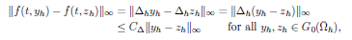

The existence of C is the result that h is a linear mapping between finite-dimensional spaces. This approach doesn’t provide any information regarding the behavior of the Lipschitz constant. In the case of our model problem, we can fortunately calculate all eigenvalues and eigenvectors of h, and this gives us good insight into the behavior of the system. Before we consider the two-dimensional problem, we first take a look at the approximation of the one-dimensional Poisson equation.

And the space

Of grid functions. central difference approximation of the second derivative is given by

Lemma 3.2 (One-dimensional eigenvectors)
We Define

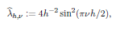

Then we have

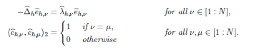

Proof. For the first result, we make use of the trigonometric identities.

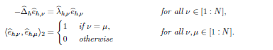
Then we have

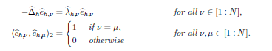

Proof. For the first result, we make use of trigonometric identities

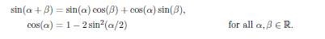
Proof. For the first result, we make use of the trigonometric identities

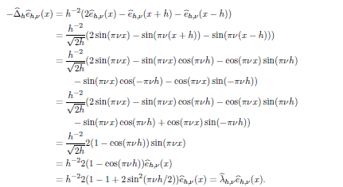

For the second result, we apply the trigonometric identity

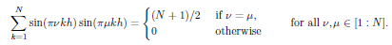

Let v, u belongs to [1 : N]. We have

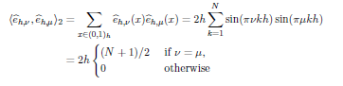
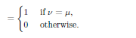
We have found a complete orthonormal basis of Go([0; 1]h) consisting of eigenvectors in the one dimensional case. Since the two-dimensional case is closely related, our results carry over directly.

Lemma 3.3 (Eigenvalues)
We define

